Homework 1 Report
Taiyi Ouyang
Tejas Roysam

App URL: http://1-dot-modular-conduit-121504.appspot.com/

Functionality and implementation:
- Landing page displays most recent 5 posts and a sidebar with links to:
  - Archives – another page with the same layout that contains all the posts, including older ones, made to the blog. This page contains the same information in its sidebar as the landing page.
  - Sign in/Sign out – redirects the user to the Google login page, where they can sign in with their email and password
  - Subscribe/Unsubscribe – Appears once the user has signed in, and allows them to subscribe to daily emails sent at 5pm to their inbox containing a summary of blog activity for that day.
- Posts on the landing page and the archive page are structured as a block with a distinct title, email, date, and message displayed. They are ordered by time in descending order.
- Once a user has logged in, they can create a post by clicking the appropriate link, which will take them to a new page. They then enter their desired title and message body, and can then submit their message. If the user is not logged in, they are instructed that they cannot post unless they log in and should return to the home page.
- User posts persist in a data store implemented with the objectify appengine library.
- The styling of the blog uses a simple inoffensive background color, with a title and image header on the main pages, as well as a sidebar to organize relevant information.

Screenshots:
  - Home page
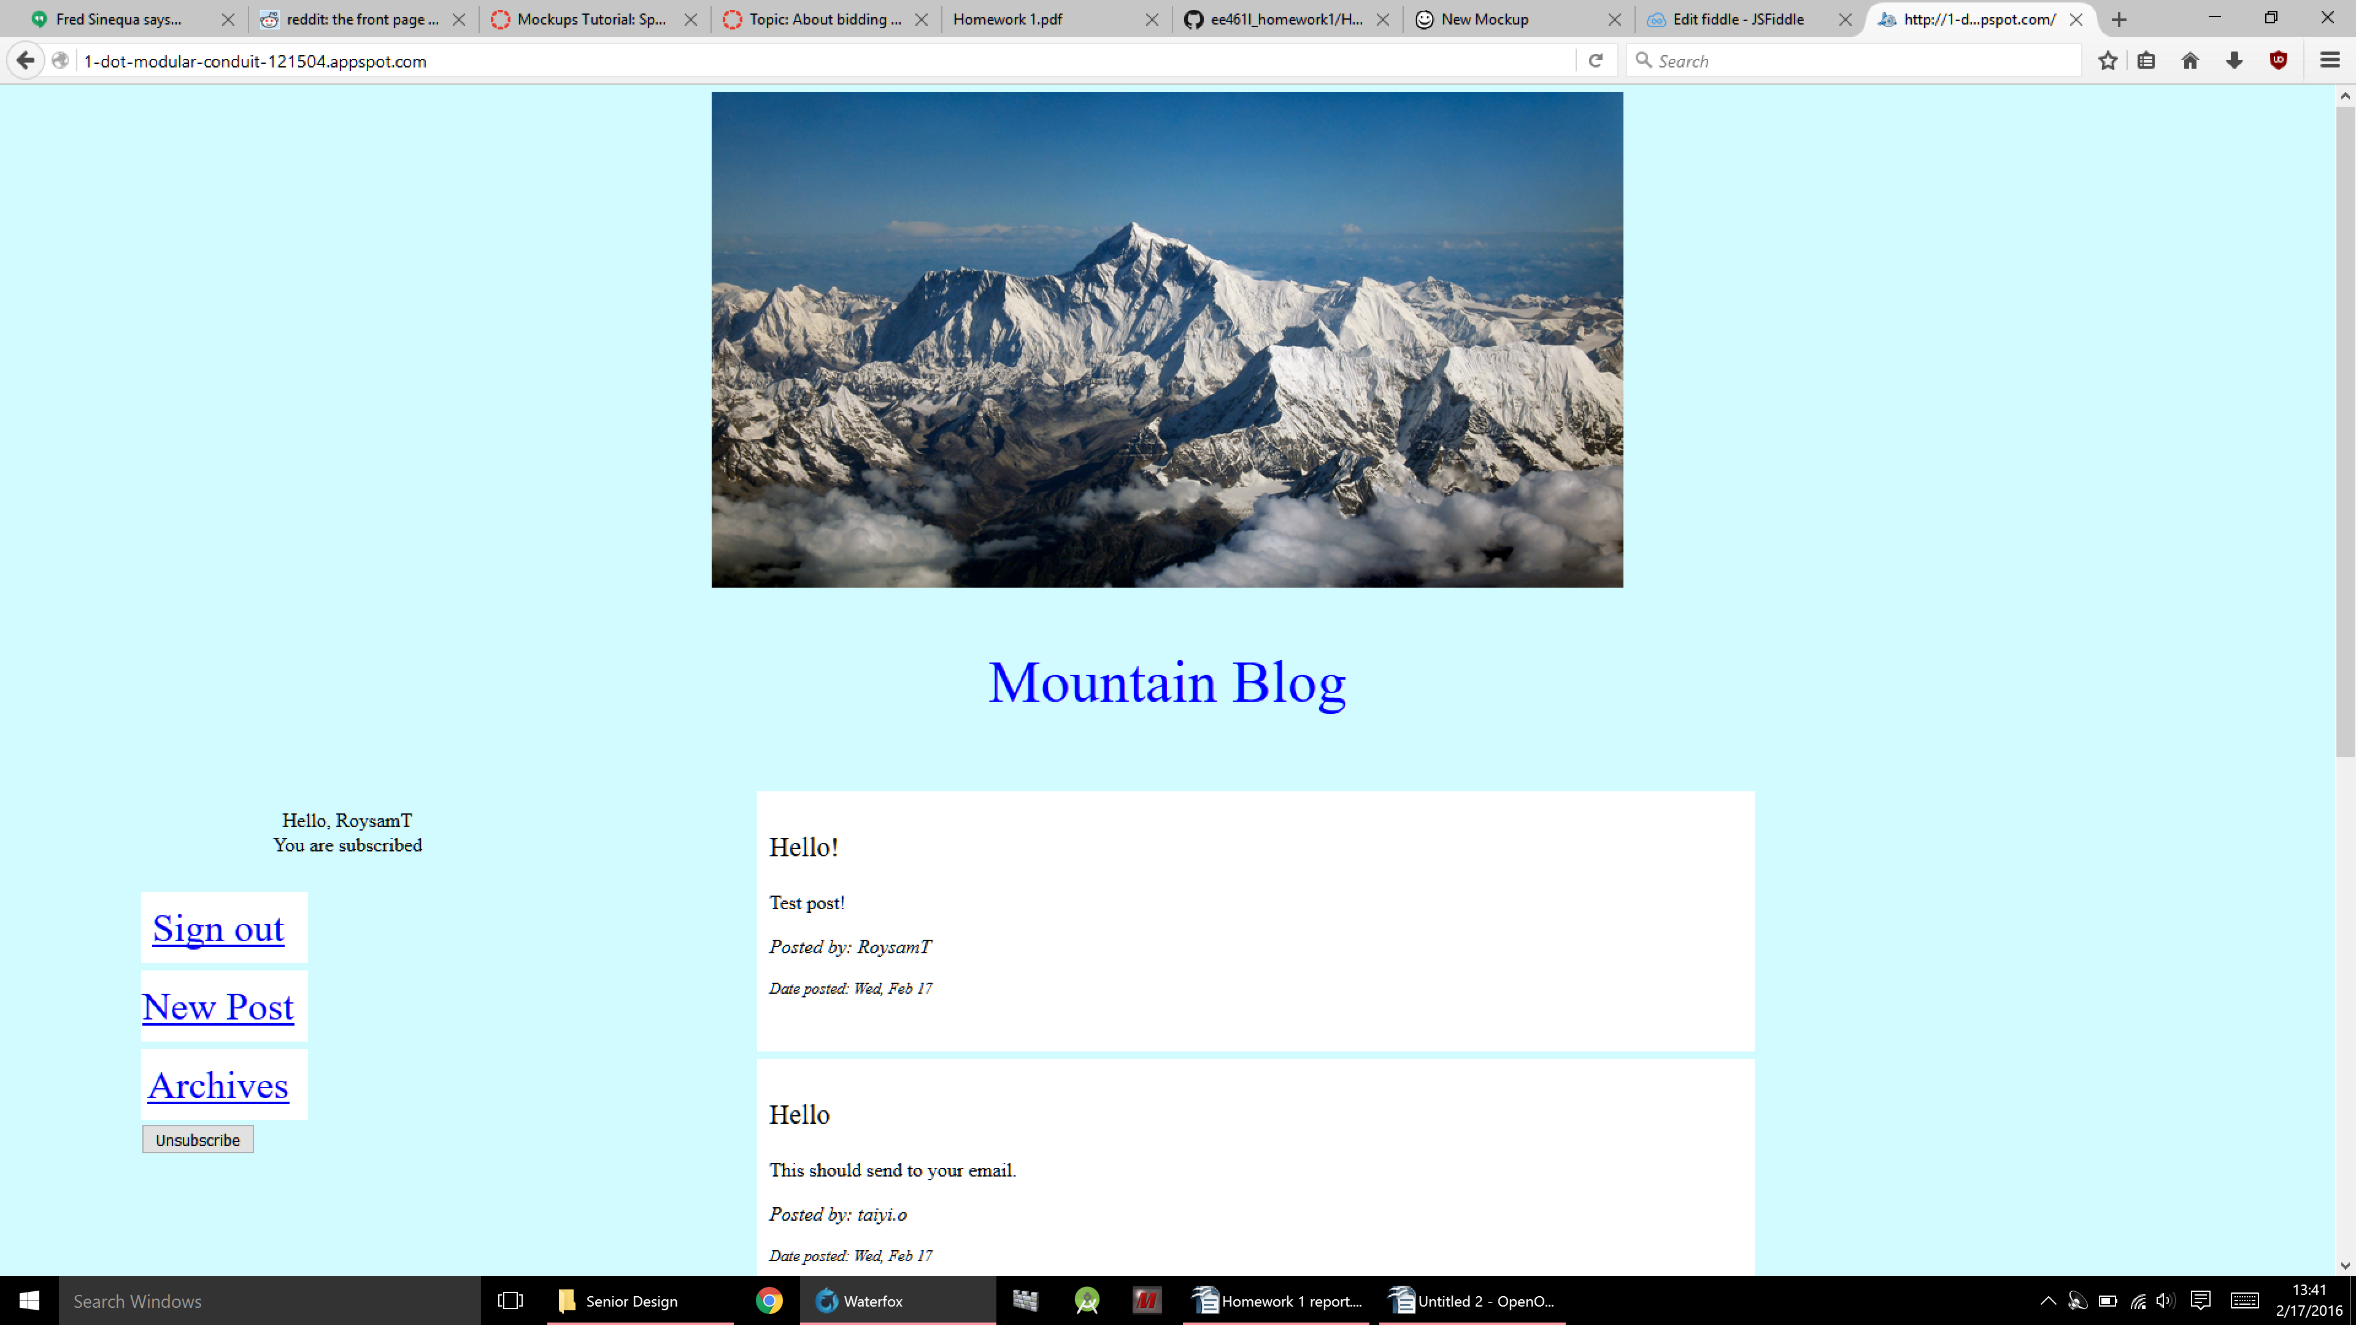
  - Archive Page
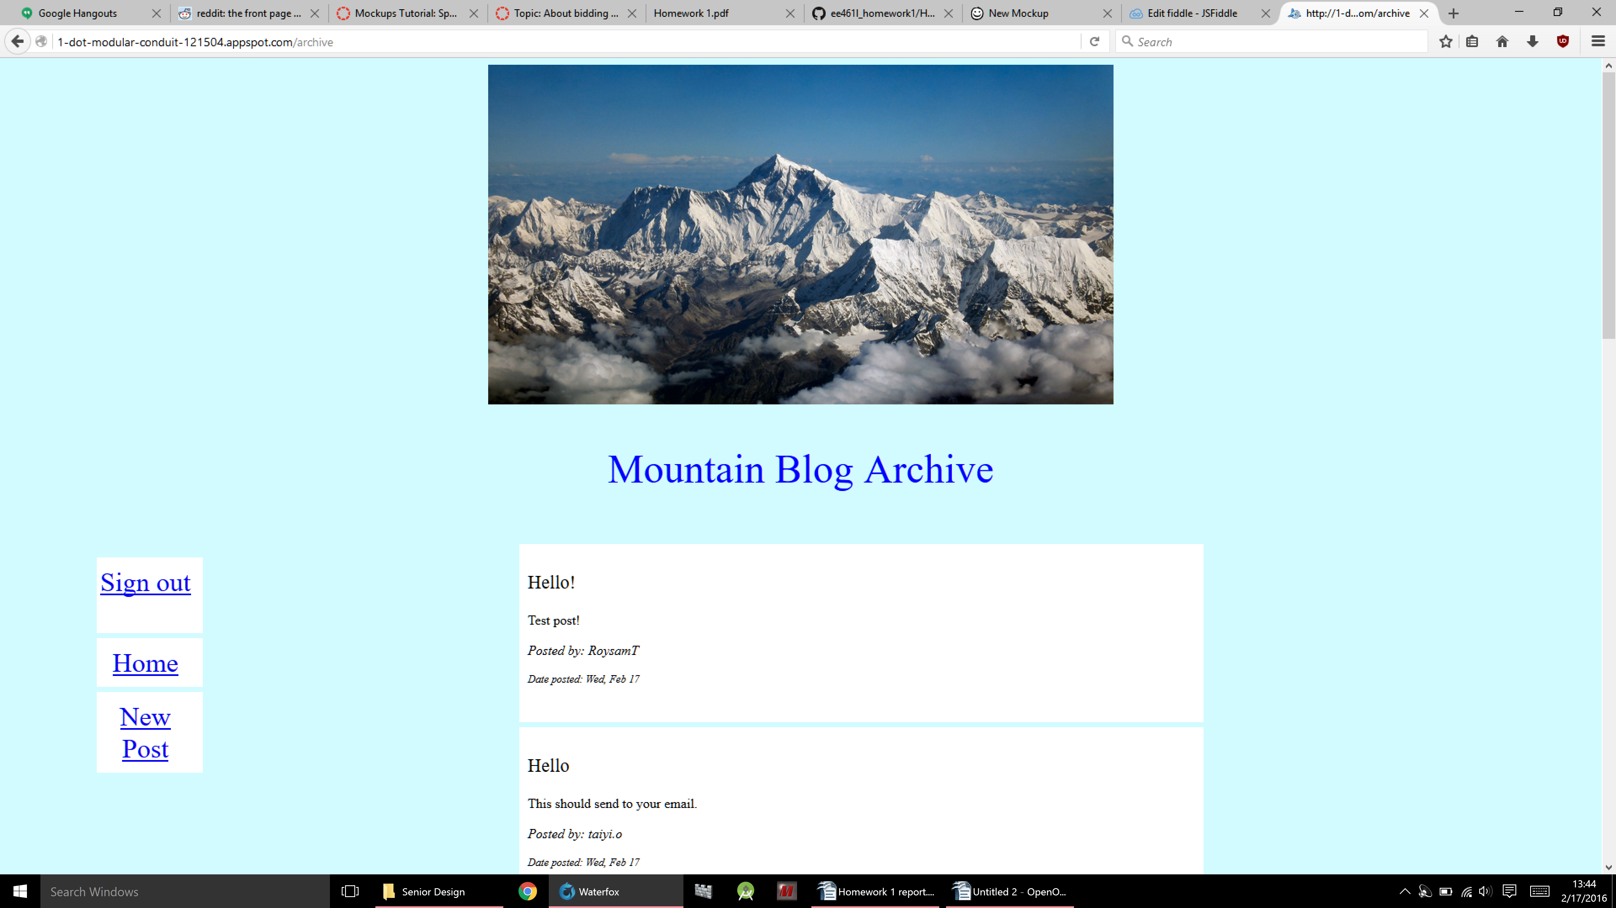
  - New Post Page
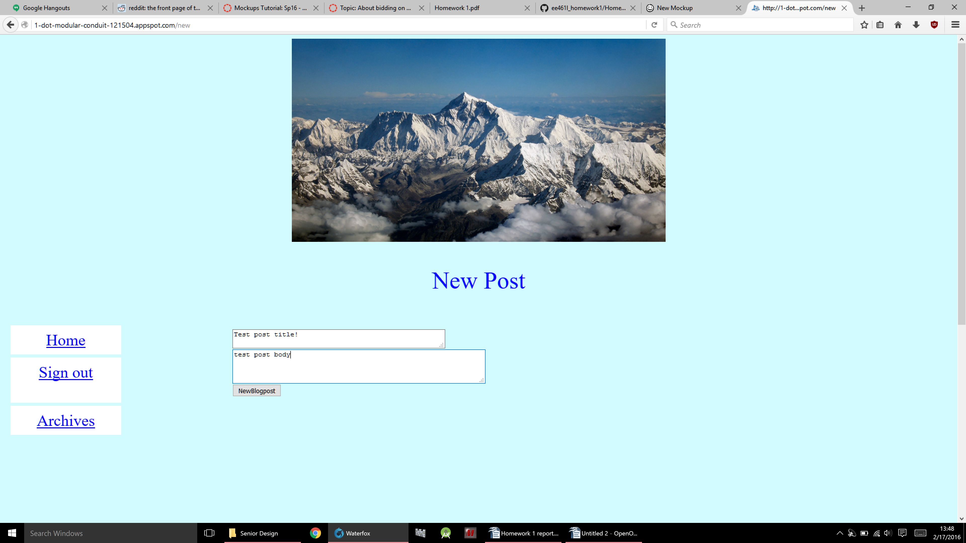

Collaboration:
- Taiyi performed the majority of the work, as he had started before the partnership was formed. He wrote the majority of the javascript and HTML portions, while Tejas helped with the CSS and debugging.
- Taiyi has had experience in HTML and CSS before, and is very skilled with creating webpages. Tejas needs to spend more time learning that skill, but has a good grasp of javascript.

